Overall Notes.

>>> Two working examples (click through) required:

1. User
2. Location Manager

Click Through issues

>>>> when selecting a schedule such as



The calendar that pops up has the following issues

1. TOO BIG for screen… cannot scroll down to bottom at all. Please fix

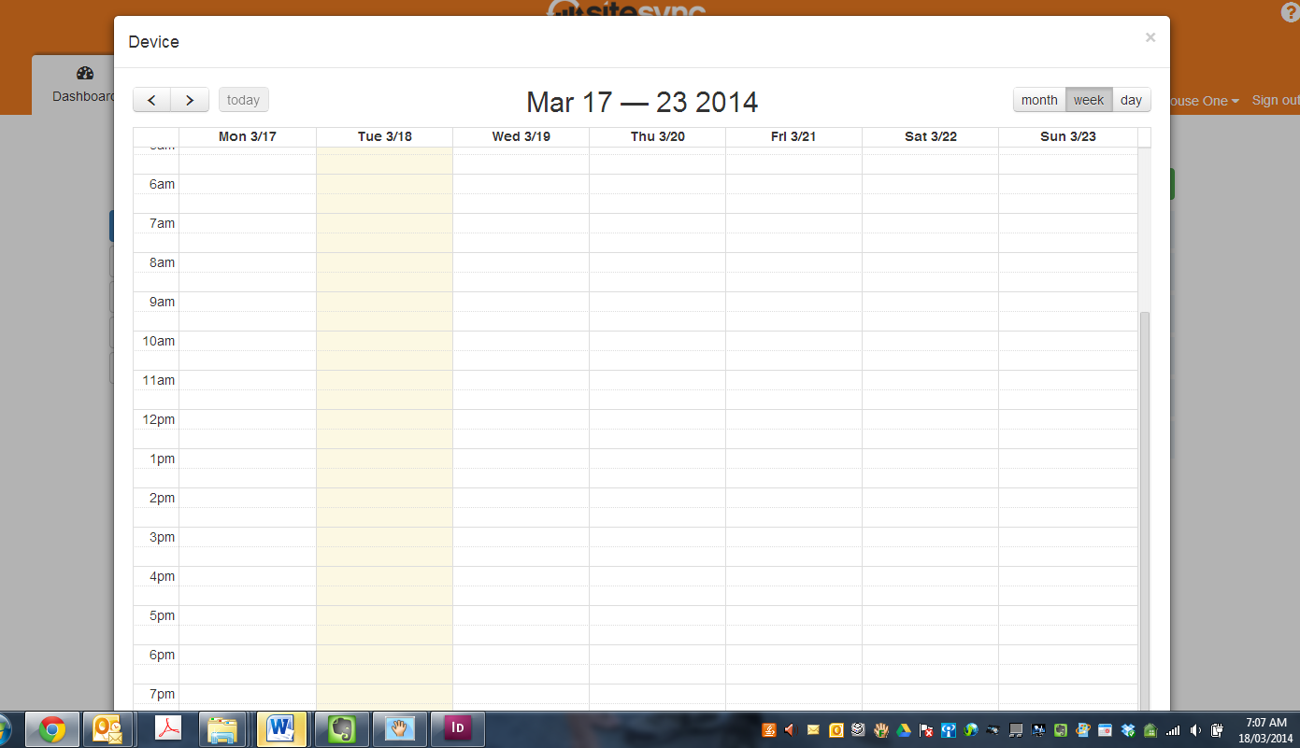

1. When clicking an area to make a schedule **nothing happens**. Please fix
2. For the sake of the click through we selected the schedule tab to show the option screen below which requires changes as per the visual example accompanying this document.

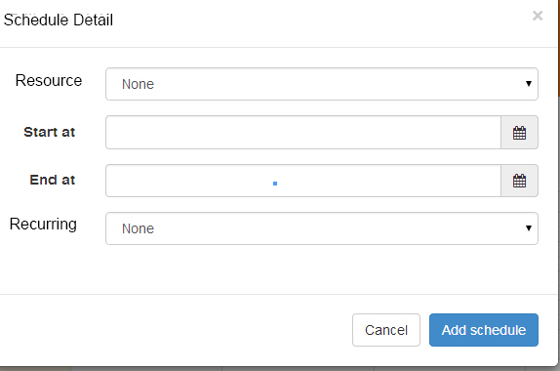

1. When finished selecting date and time. Have an OK box PLUS click away to accept the input. Currently neither work. And it gets stuck. Refer to visual example.

